Project Design Phase
Problem – Solution Fit Template

Date | 29 June 2026
NAME | VARSHINI S
Project Name | Metro Ticket Generating System in ServiceNow
Maximum Marks | 2 Marks

Problem – Solution Fit Template:
The Problem–Solution Fit for the Metro Ticket Generating System in ServiceNow demonstrates a direct alignment between the challenges faced by passengers during manual ticket booking and the automated digital ticketing solution developed using the ServiceNow platform. The solution simplifies the ticket booking process by providing an online self-service portal, automated workflow execution, secure data storage, and QR code-based ticket verification. It validates that the implemented solution addresses real-world metro ticket booking requirements while improving efficiency, accuracy, and user experience
Purpose:
• Fits the User's Context: Enables passengers to book metro tickets anytime through the Service Portal without visiting physical ticket counters, reducing waiting time and improving convenience.
• Leverages Familiar Behaviour: Uses a simple and user-friendly ServiceNow Catalog form with intuitive fields such as Source Station, Destination Station, Number of Passengers, Journey Type, and Fare, allowing users to complete bookings with minimal effort.
• Provides Clear Status Updates: Automatically generates Request, RITM, and approval status notifications, allowing users to track their booking progress and ensuring transparency throughout the ticket generation process.
• Eliminates Manual Errors: Prevents incomplete or incorrect ticket requests by implementing mandatory field validation, UI Policies, Catalog Client Scripts, Flow Designer automation, and Access Control rules, thereby improving data accuracy and reducing administrative effort.
• Optimizes Metro Operations: Automatically stores passenger details in a custom Metro Station Details table, generates QR code information for ticket verification, and creates a centralized database that can support future enhancements such as online payment integration, email notifications, travel history, analytics dashboards, and mobile ticketing.

•

Template:
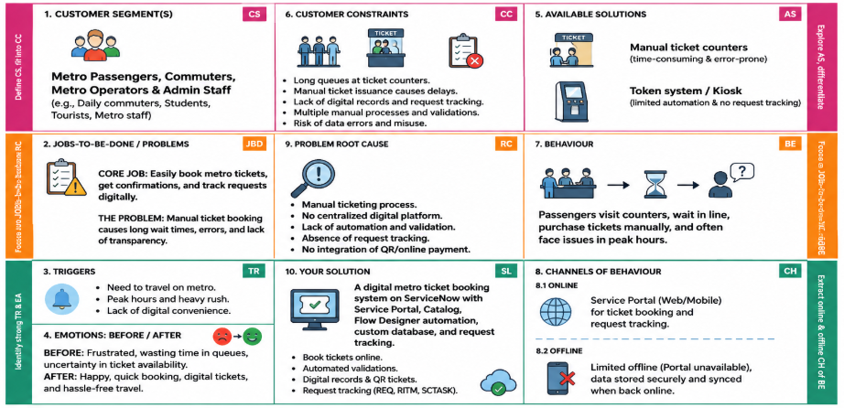

References:
1.https://www.ideahackers.network/problem-solution-fit-canvas/
2. https://medium.com/@epicantus/problem-solution-fit-canvas-aa3dd59cb4fe

